Mongolian blue spots

Definition
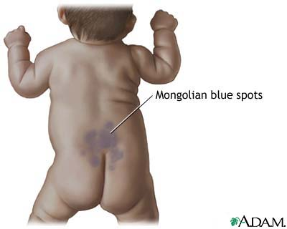
Mongolian spots are flat, blue, or blue-gray skin markings near the buttocks that commonly appear at birth or shortly thereafter. Mongolian blue spots are common among darker skinned persons, such as those who are of Asian, East Indian, and African descent. Mongolian spots are noncancerous skin markings and are not associated with disease. The markings may cover a large area of the back. Occasionally, Mongolian blue spots are mistaken for bruises, which can raise a question about possible child abuse. It is important to recognize that Mongolian blue spots are birthmarks, NOT bruises.
Symptoms include:
- Blue or blue-gray spots on the back, buttocks, base of spine, shoulders, and other body areas
- Flat area with irregular shape and unclear edges
- Normal skin texture
- The spots are usually 2 - 8 centimeters wide
No treatment is necessary or recommended. The spots often fade in a few years and are almost always gone by adolescence.
